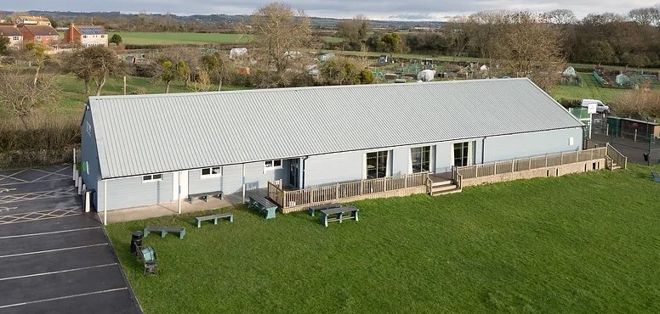
MIDDLEZOY VILLAGE HALL, NETHERMOOR ROAD, MIDDLEZOY,
TA7 0PG
Managed by the Voluntary Hall Management Committee hereafter referred to as MCP (Middlezoy Community Project)

Please complete this form in block capitals if handwritten, and return to middlezoyvillagehallbookings@gmail.com
Our bookings secretary will be in touch with you regarding your booking.
Should you wish to ask any questions prior to completion of this form, please call Angela on 07885 195 418
A deposit of £100 is required when booking and will be returned if all clauses in the terms and conditions (T&Cs) are met. Our treasurer with be in contact with you, via email, regarding payment.
Booking fees can be found at: https://www.middlezoyvillagehall.org.uk/mvh-bookings

BOOKING INFORMATION
Name of Hirer/Organisation:
Telephone:
Address:
Postcode:
Email Address:

Name of Responsible Person (The ‘Responsible Person’ must be over 18 years of age) This is the person who must sign the Booking Form, and that they have read and will adhere to the T&Cs attached.
Name:

PURPOSE OF HIRE

Please select day/s & Indicate times of hire. Please consider setting up and clearing of your event as per the T&Cs and make allowances with your hire timings.

Event Theme/Title:
Hire Date/s:

Please select day/s & Indicate times of hire (including setting up and clearing):
 | Monday | Tuesday | Wednesday | Thursday | Friday | Saturday | Sunday
Start
Finish

Estimated numbers likely to attend: | Age Range:

USE OF FACILITIES – Please cross out answer not required.
Do you require use of kitchen facilities? | YES | NO
Do you wish to hire the cutlery sets? | YES | NO
(Up to 120 people within hall costs; additional cost of £5 per set of 30)
Please state extra number of people to attend needing cutlery:

Is alcohol to be sold by event organisers on the premises? | YES | NO
If 'YES' to selling alcohol the consent of the MCP must be obtained through the Booking Secretary, and a copy of your Licence or Temporary Licence must be shown to the Booking Secretary at least 7 days prior to the event.

NB. The Hall Bar area, including glasses, are not available to use by the hirer. Please speak to our Booking Secretary how you can ‘build’ a bar area to sell from.
Would you like the MCP to provide the bar and staff to sell to your attendee’s? | YES | NO
If YES, a fee of £50 will be charged.
If the MCP provide a bar for your event, please state the time you wish to open the bar, and the time you wish it to be closed. (NB. no bar will be open past 11pm on any day)
Opening Time: | Closing Time:

HIRER OR RESPONSIBLE PERSON
The Hall keys must be returned upon leaving the Hall; we reserve the right to charge time at standard hourly hire rate until the keys are returned.
I hereby confirm that I understand and agree that I am the Hirer or Responsible Person and will be held responsible for the booking.
Name in Block Capitals:
Signature: | Date:

I hereby confirm that I have read, understood, and agree with the T&Cs for the Hall Hire.
Name in Block Capitals:
Signature: | Date:

CANCELLATIONS
14 days’ notice must be given or forfeit of your deposit.
UNTIL THIS FORM IS RETURNED COMPLETED TO THE BOOKING SECRETARY, AND DULY SIGNED, THE BOOKING IS PROVISIONAL AND COULD BE LOST IF ANOTHER COMPLETED BOOKING IS RECEIVED FOR THE SAME DATE/TIME.

